Astronomy Party Game
Here is a novel way to introduce a variety of astronomical objects to your students -- as well as a way to have students introduce themselves to one another!

Materials: Index cards labeled with various astronomical objects
Scotch tape

What To Do:
1. Prepare index cards at home. Each index card should contain the name of an astronomical object with a diagram or photograph (Figure 1). Make one card for every student in your class. A list of objects is attached.
Figure 1

2. Tape one card on the back of each student. Make sure students do not seen the card. Instruct students not to tell others what is on their backs. They will be playing a game where they will have to guess what object is on their back.

3. Students are to wander around the room asking each other "yes or no" questions. For example, for the card above, a student can ask "is this a planet," or "is this an object inside our Galaxy" The answer to both questions would be "yes." Students should not give more than "yes" or "no" as a response. Also, students are limited to asking each other three questions -- then they need to find a new classmate.

4. To indicate they have successfully guessed their object, students should remove the index card from their backs and attach them to their chest. However, students should still help others guess their object by answering "yes-no" questions.

What's Going On?
In this “ice breaker” activity, students are examining what they already know about astronomical objects and confronting questions or misconceptions that they might have uncovered as a result of engaging in this game.

The Moon  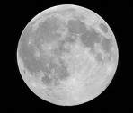 | Orion Nebula – Stellar Nursery  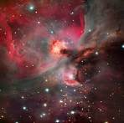
The Sun  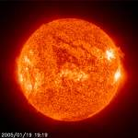 | Saturn  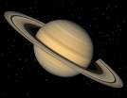
Andromeda Galaxy  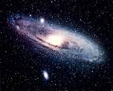 | Milky Way Galaxy  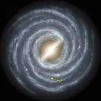
Betelgeuse – Red Giant  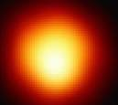 | Halley’s Comet  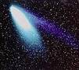
Neutron Star – Dead Star  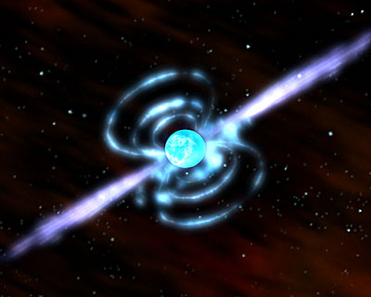 | Asteroid Belt  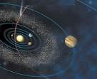
Black Hole – Dead Star  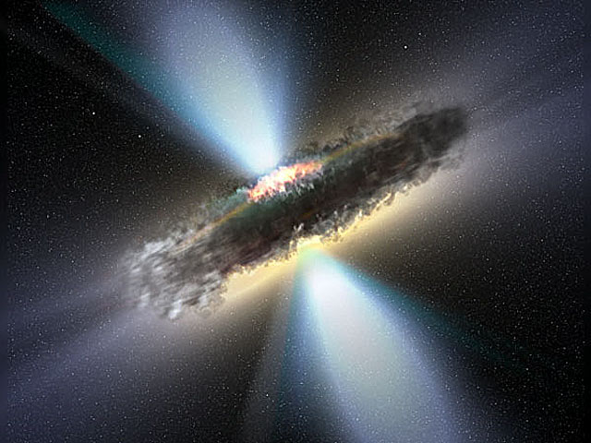 | Super Nova  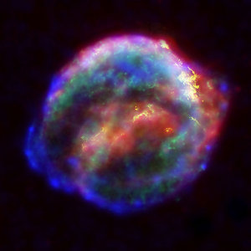
White Dwarf – Dead Star  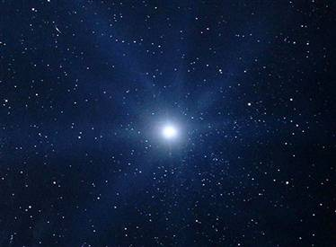 | Pleiades – Star Cluster  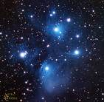
Mars  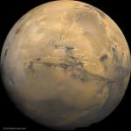 | Crab Nebula – Supernova Remnant  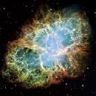
Pluto – A dwarf planet  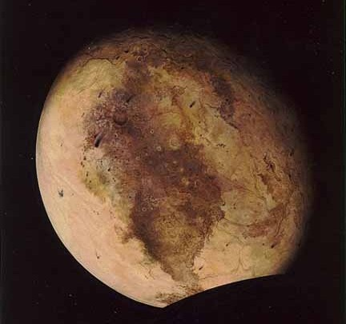 | Venus  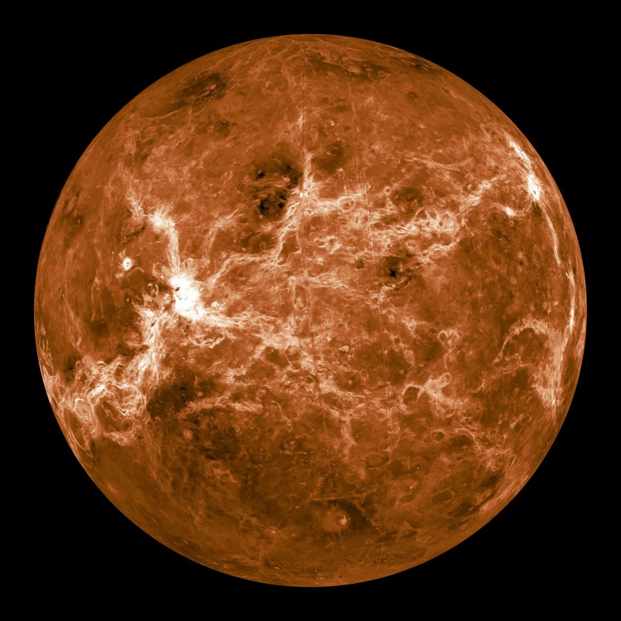
“Magellanic Clouds”  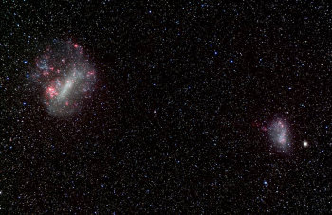 | Io – a moon of Jupiter  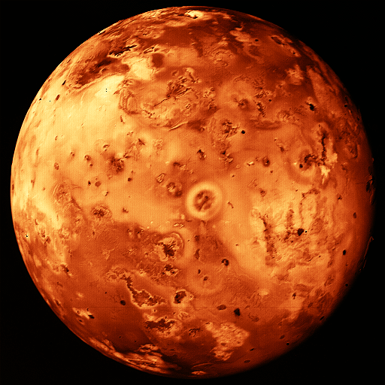
A Quasar   | 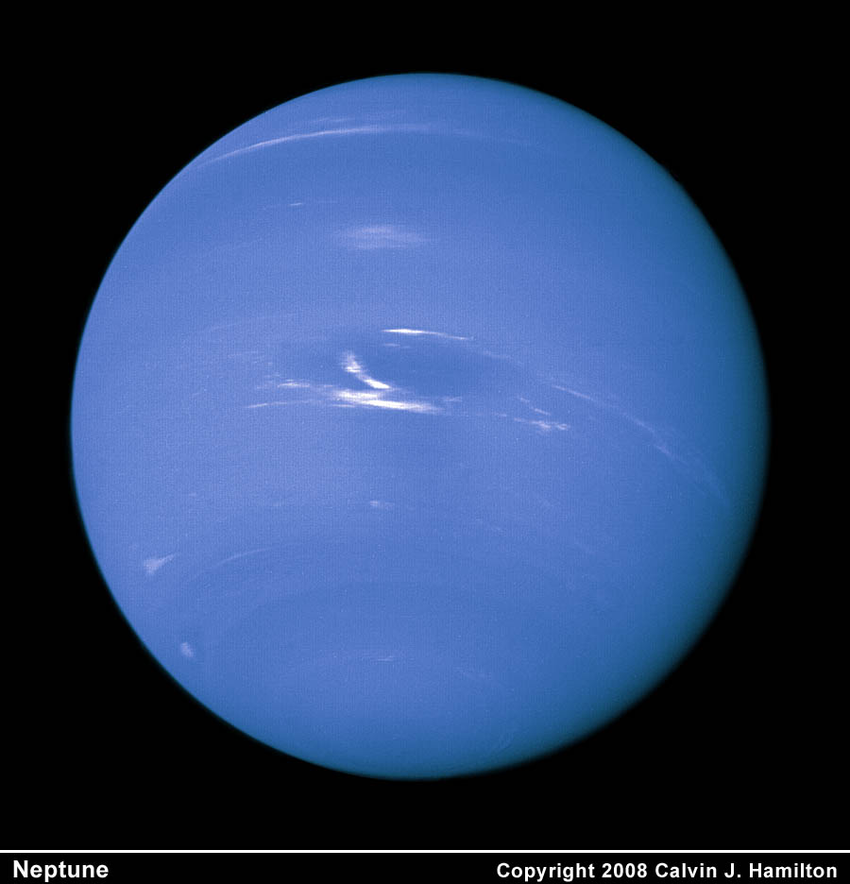  Neptune
Earth  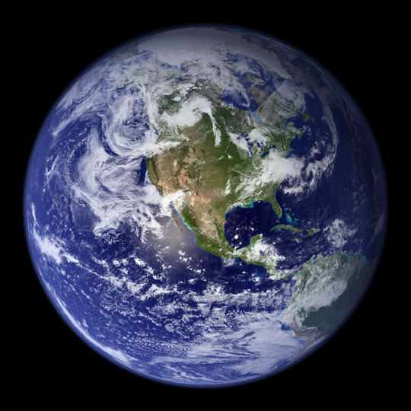 | Alpha Centauri System  