Mentos & Soda Inquiry Name: _____________________

→ Mentos & Soda Demo Data:
Type of Soda used: __________________________ Temperature of Soda: ________
Flavor of Mentos used: ______________________ # of Mentos used: _________
Qualitative description of pre-event mentos:

Quantitative measurements of event: | Qualitative descriptions of event:
1.
2.
3.

Qualitative description of post-event mentos:

→ What happened?!?!
1. Brainstorm a hypothesis with your group that describes the cause of the mentos/soda pop event. Write your hypothesis here:

2. What are some factors or variables that you think could affect the strength of the event?

Wait until your instructor tells you to fill in the next part!
3. Independent Variable Question

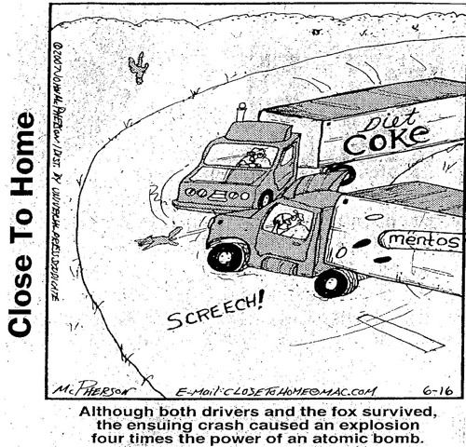
→ Group Experiment
Question: Write down the specific question that your group will answer:

Hypothesis: Write your hypothesis about your group question, stating how you think the variable will affect the height of mentos/soda pop volcano. Be sure to say why you think what you think!

Procedure: Write a numbered procedure for the experiment that you will perform to answer your question. Be as clear as possible about the number of items you will use and what you will measure. Make sure your experiment will give you data that can support or refute your hypothesis. Get this stamped by your instructor before you begin!

Data: Make a chart to record your data. (Note: this should include information similar to what we recorded during the demo!)

Conclusion: (5 sentence paragraph) State the question that you were attempting to answer. Write one sentence summarizing what you did and what you observed. Describe any problems you encountered or errors that occurred during your experiment. State your hypothesis and say if it was supported or refuted by the data you obtained. Lastly, write a general statement about how the variable you tested affects the mentos/soda pop volcano.

→ Whole Class Analysis:
Group Variable Description of Effect

Write a 2-3 sentence explanation of what you think is the most likely cause of the mentos/soda pop volcano.

What further experiment(s) should be done to test your new hypothesis?

→ At Home Research:
See if you can find information online that gives an explanation of the phenomenon studied in class. Write a 2-3 sentence summary of what you found online, be sure to include the web address(es) where you obtained your information.

Source(s):

