The Oobleck Please work on binder paper!

Background - Oobleck
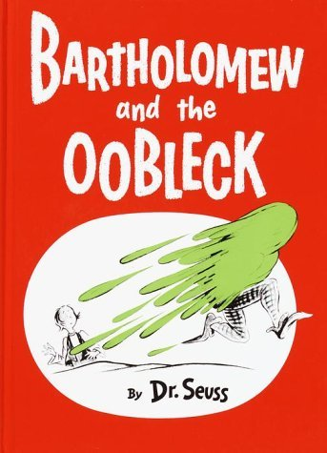
Believe it or not, we’re going back to our childhood days of reading Dr. Seuss in this high school Chemistry class! In his characteristically imaginative way, Dr. Seuss describes a green goop / glop / gloop in his book Bartholomew and the Oobleck. In his story, green Oobleck fell from the sky by the hands of wizards. In our class, we’re going to use our laboratory skills to make the stuff. Turns out it’s a simple recipe consisting of corn starch and water! So, what makes Oobleck especially fascinating? It’s a ‘non-newtonian fluid’. That means it has properties of a liquid when you move it slowly and properties of a solid when you move it quickly. The viscosity of the fluid depends on the amount of force being applied to it. In other words, it can ooze and it can shatter! Pretty cool.

Background - The Scientific Method
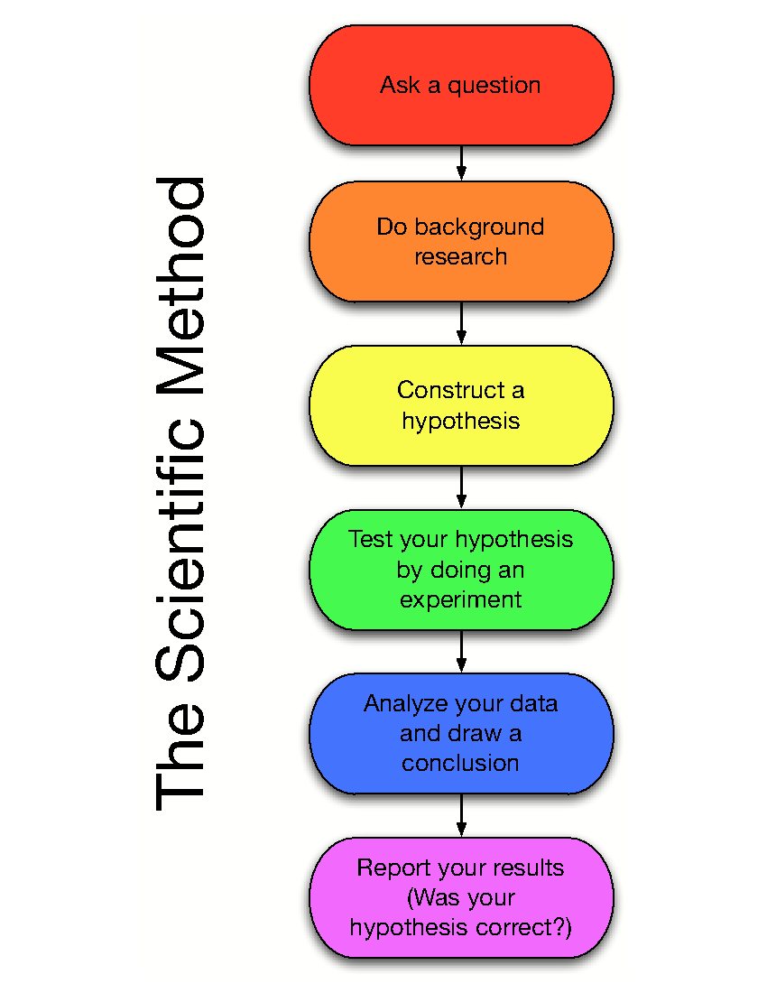
Doing science means relying on what can be observed and measured in the physical world in order to draw conclusions. In this class we will be doing a large number of experiments through out the year to observe and confirm what we are learning in the textbook. There will also be opportunities for ‘inquiry’, where you, as the student, get to direct some of the experimentation. Traditionally, a scientist starts with a question or problem, develops a hypothesis, designs an experiment, performs the experiment, analyzes data, draws conclusions, and reports findings. In the past, you may have been taught to view this as a linear process, like the graphic to the left. In actuality, the process of doing science is cyclical. After drawing conclusions, the researcher may refine their question, change their hypothesis, or modify the experiment. There are many arrows linking the ‘steps’ of the scientific method… it’s almost like a web or a spiral with arrows connecting many different points.
TURN OVER TO SEE YOUR ASSIGNMENT!
The Oobleck Assignment
For this activity we will use the scientific method to make the best recipe for Oobleck. On your binder paper you will answer the numbered questions below as you work with your group. Begin by writing a title at the top of your paper and putting your name, the date, and class period on the upper right hand corner of the page. Part of this assignment will be graded on how well you follow the instructions on this page.

Part I: Goal
1) What is the goal of this activity?

Part II: Hypothesis
2) Think about cornstarch and water and how they might mix. Predict a ratio of cornstarch to water that you think will be the best for the Oobleck. State why you think this is a good ratio.

Part III: Plan
In every aspect of our lives, we should approach problem-solving in a systematic way. Guessing & checking can work in some situations, but more often having a strategy to solve a problem works out better. With your group decide on a strategy for determining the best ratio of corn starch to water for the Oobleck. Limitations: The total volume of cornstarch available to your group, for ALL of your trials, is: ______________________ (Ask your teacher if you don’t already know!)
3) Write a one-sentence summary of your strategy for how to develop the best recipe.
4) What materials will you need to carry out your plan?

Part IV: Record your data
5) Make a chart (data table) showing the volumes of cornstarch and water that you test while trying to develop the best recipe. Determine the ratio of these two ingredients. For example, 1 tbsp of cornstarch with 0.5 tbsp water would be a ratio of 2:1.
Include columns for what you will look for to decide if the Oobleck is the desired consistency (stretchy-ness, ooziness, shattering). Include units on your numerical values (for example, ‘1’ corn starch could be ‘1 teaspoon’, ‘1 tablespoon’, ‘1 ton’… no “naked” numbers!)

Part V: Communicate your findings
6) You will write a numbered, step-by-step procedure for how to make Oobleck according to your best recipe. It should be so clear that ANYONE can follow your instructions!

Part VI: Reflect / Revisit
7) What would you change about the way your group approached this problem?
8) Draw a cyclical version of the scientific method based on the description in the background. Use words that make sense to you (for example, maybe you like the word ‘problem’ more than ‘question’, or maybe you want to use both… use the terms that you like), BUT be sure to include all of the key parts. Connect with arrows in all the appropriate places.

